**Process scheduling concepts**

**First Come First Serve (FCFS)**

As the name suggests, the process coming first in the ready state will be executed first by the CPU irrespective of the burst time or the priority. This is implemented by using the **First In First Out (FIFO)** queue. So, what happens is that, when a process enters into the ready state, then the PCB of that process will be linked to the tail of the queue and the CPU starts executing the processes by taking the process from the head of the queue (learn more about PCB from [here](https://afteracademy.com/blog/process-control-block-in-operating-system)). If the CPU is allocated to a process then it can't be taken back until it finishes the execution of that process.

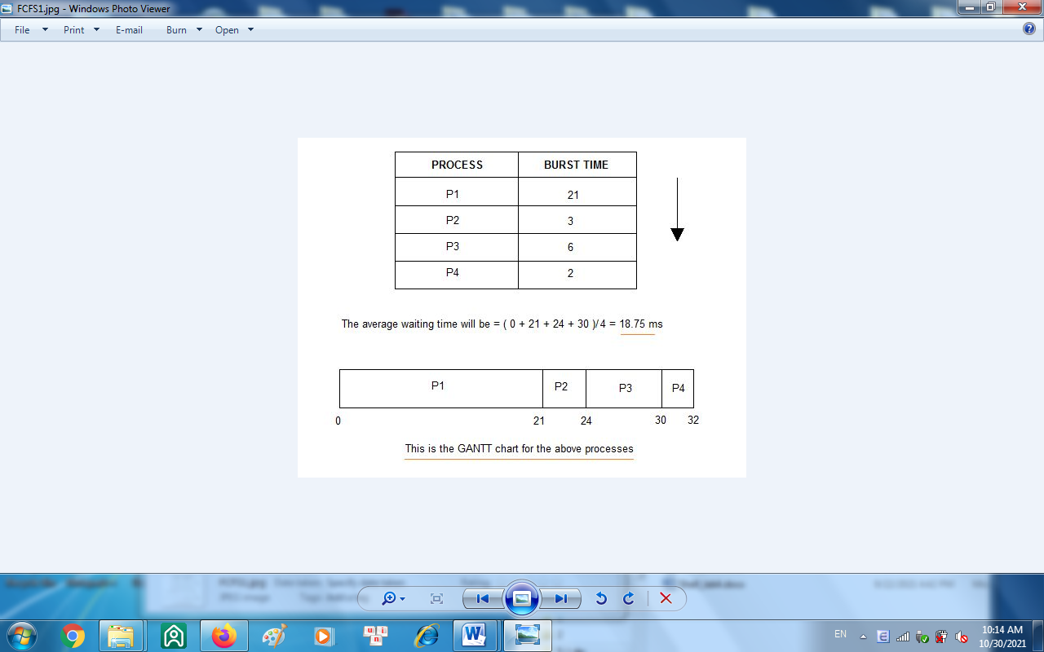

**Shortest Job First Scheduling (SJF)**

**Shortest Job First (SJF)** is an algorithm in which the process having the smallest execution time is chosen for the next execution. This scheduling method can be preemptive or non-preemptive. It significantly reduces the average waiting time for other processes awaiting execution. The full form of SJF is Shortest Job First.

